**TABLE OF CONTENTS**

|  |  |  |
| --- | --- | --- |
| Chapter | Contents | Page.no |
|  | Abstract | 4 |
|  | Introduction to project | 5 |
|  | Arduino | 6 |
|  | LCD display | 7 |
|  | Heart rate module | 8 |
|  | Circuit diagram | 9 |
|  | Connections | 10 |
|  | Working of the model | 11 |
| 8. | Advantages | 12 |
| 9. | Disadvantages | 12 |
| 10. | Conclusion | 13 |
| 11. | Reference | 13 |

**ABSTRACT**

Heart rate, body temperature and blood pressure monitoring are very important parameters of human body.

Doctors use various kinds of medical apparatus like thermometer for checking fever or body temperature, BP monitor for blood pressure measurement and heart rate monitor for heart rate measurement.

In this project, we have built anArduino based heartbeat monitorwhich counts the number of heartbeats in a minute.

Here we have used aheartbeat sensor module which senses the heart beat upon putting a finger on the sensor.

**INTRODUCTION TO THE PROJECT**

A heart rate monitor is a personal monitoring device which allows one to measure his or her heart rate in real time or record the heart rate for later study. It is largely used by performers of various types of physical exercise.

Widely used in hospitals for checking the health of patients.

More than 2 million people are at high risk of having heart attack.

It would be helpful if there was a way for these people to monitor their heart. So we have a problem . That is the way our project focuses on how we can utilize this problem and find the solution

**COMPONENTS:**

|  |  |  |  |
| --- | --- | --- | --- |
| **S:No.** | **Components** | **Range/Model/Number** | **Quantity Required** |
| 1 | Arduino | Uno R3 | 1 |
| 2 | Heart beat sensor module | SEN - 11574 | 1 |
| 3 | 16*2LCD | LM016L, HD44780U | 1 |
| 4 | Push button | - | 2 |
| 5 | Bread board | - | 1 |
| 6 | Resistor | 1KΩ | 1 |
| 7 | Connecting wire |  | 21 |
| 8 | Preset | 10 KΩ | 1 |

**AURDINO**

* Arduino is a single-board microcontroller.
* Intended to make the application of interactive objects and environments more easier.
* Basically this is very user friendly.There is microcontroller unit embedded on it 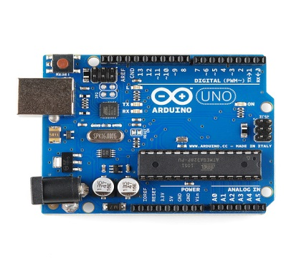
* The code is directly loaded from the computer.
* The Arduino microcontroller is an easy to use yet powerful single board computer.
* It has gained considerable traction in the hobby and professional market.
* The Arduino is open-source.
* Which means hardware is reasonably priced and development software is free.

**LCD DISPLAY**

* This means 16 characters per line by 2 lines and 20 characters per line by 2 lines, respectively.
* The standard is referred to as HD44780U, which refers to the controller chip which receives data from an external source (and communicates directly with the LCD.
* Most common LCDs connected to the microcontrollers are 16x2 and 20x2 displays.

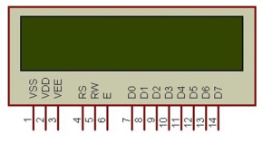

* If an 8-bit data bus is used the LCD will require 11 data lines

(3 control lines plus the 8 lines for the data bus)

* The three control lines are referred to as EN, RS, and RW
* EN=Enable (used to tell the LCD that you are sending it data)
* RS=Register Select (When RS is low (0), data is treated as a command.
* (When RS is High(1), data being sent is text data )

**HEART RATE MODULE**

The heart rate Sensor can be connected to arduino, or plugged into a bread board.The front of the sensor is the pretty side with the Heart logo. This is the side that makes contact with the skin. On the front you see a small round hole, which is where the LED shines through from the back, and there is also a little square just under the LED. The square is an ambient light sensor, exactly like the one used in cellphones, tablets, and laptops, to adjust the screen brightness in different light conditions. The LED shines light into the fingertip or earlobe, or other capillary tissue, and sensor reads the light that bounces back. The back of the sensor is where the rest of the parts are mounted.

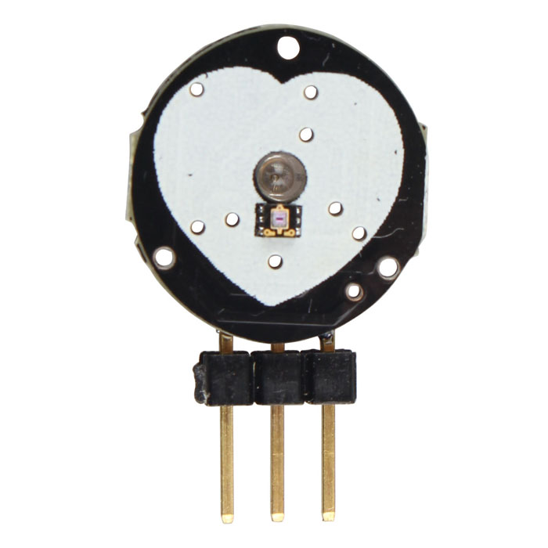

**CIRCUIT DIAGRAM**

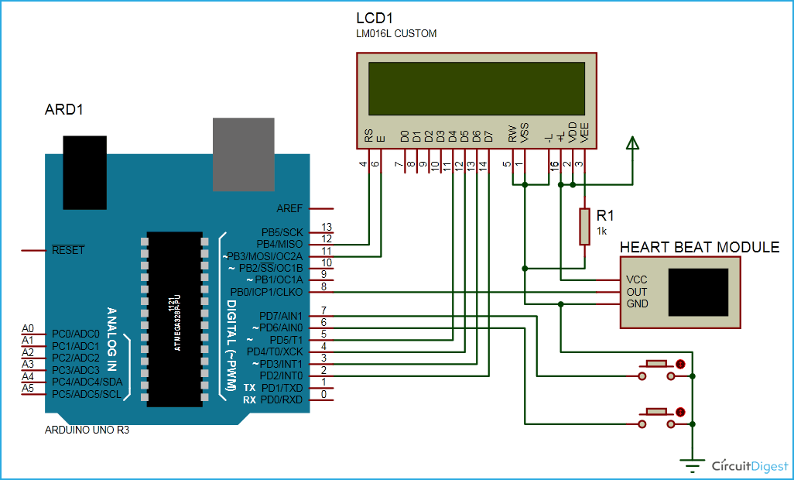

**CONNECTIONS**

In this project Aurdino controls whole the process of system like reading pulses from heart beat sensor module, calculating heart rate and sending this data to LCD.We can set the sensitivity of this sensor module by inbuilt potentiometer placed on this module.

Heart beat sensor module's output pin is directly connected to pin 8 of Arduino.Vcc and GND are connected Vcc and GND.A 16*2 lcd is connected with arduino in 4_bit mode. Control pin RS,RW and EN are directly connected to arduino pin 12, GND and11.And data pin D4_D7 is connected to pins 5,4,3,2 of arduino. And one pushbutton is added for resetting reading and another is used to start the system for reading pulse.When we need to count heart rate ,We press start button then arduino start counting pulses and also start counter for five seconds.This start push button is connected to pin 7 and reset pushbutton is connected to pin 6 of arduino with respect to ground.

**WORKING OF THE MODEL**

In this project we have used heart beat sensor module to detect heartbeat .This sensor module contains an IR pair which actually detect heart beat from blood. Heart pumps the blood in body which is called heart beet, when it happens the blood concentration in body changes. And we use this change to make a voltage or pulse electrically.

Working of this project is quite easy but a little calculation for calculating heart rate is required. There are several methods for calculating heart rate, but here we have read only five pulses. Then we have calculated total heart beat in a minute by applying the below formula:

Five_pusle_time=time2-time1;

      Single_pulse_time= Five_pusle_time /5;

      rate=60000/ Single_pulse_time

where time1 is first pulse counter value

time2 is list pulse counter value

rate is final heart rate.;

When first pulse comes, we start counter by using timer counter function in arduino that is millis();. And take first pulse counter value form millis();. Then we wait for five pulses. After getting five pulses we again take counter value in time2 and then we substarct time1 from time2 to take original time taken by five pulses. And then divide this time by 5 times for getting single pulse time. Now we have time for single pulse and we can easily find the pulse in one minute, dividing 600000 ms by single pulse time.

Rate= 600000/single pulse time

**ADVANTAGES**

* A heart rate monitor is a fantastic tool giving you clear indication and evaluation of the condition of your cardiovascular system during physical activity.
* Indicates your heart’s ability to “recover” from a given exercise and or interval within a workout once again giving you more info on the condition of your cardiovascular system.

**DISADVANTAGES**

* In accurate method of calculating heart beat.
* Logic used is very simple. Therefore, results may vary as for a sophisticated instrument for the same purpose

**CONCLUSION**

In this project, the design and development of a low cost heart rate monitoring device is presented. The device is ergonomic, portable, durable and cost efficient. The heart rate monitoring device is efficient and easy to use. The device could be further developed into a continuously monitoring device that could be used to detect the heart beat anomalies associated with certain heart conditions.

**REFERENCES**

GOOGLE SEARCH

WIKIPEDIA

PROJECT EDU.IN

MINI PROJECTS IDEAS

Sources Document